1.2 I can assess the suitability of development environments for given projects

Visual studio

**Net-informations.com**

* [**Home**](http://net-informations.com/)

* [**C#**](http://csharp.net-informations.com/)

* [**VB.NET**](http://vb.net-informations.com/)

* [**JAVA**](http://net-informations.com/java/default.htm)

* [**Python**](http://net-informations.com/python/default.htm)

* [**JavaScript**](http://net-informations.com/js/default.htm)

* [**jQuery**](http://net-informations.com/jq/default.htm)

* [**ASP.NET**](http://asp.net-informations.com/)

* [**Data Science**](http://net-informations.com/ds/default.htm)

* [**Interview Questions**](http://net-informations.com/faq/default.htm)

**C# Visual Studio IDE**

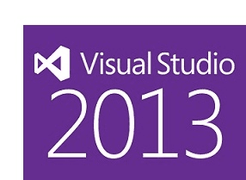

Visual Studio is the Integrated Development Environment in which developers work when creating programs in one of many languages, including C#, for the .NET Framework . It is used to create console and graphical user interface (GUI) applications along with Windows Forms or WPF (Windows Presentation Foundation) applications, web applications, and web services in both native code together with managed code for all platforms supported by Microsoft Windows, Windows Mobile, Windows CE, .NET Framework, .NET Compact Framework and Microsoft Silverlight.



It offers a set of tools that help you to write and modify the code for your programs, and also detect and correct errors in your programs. Visual Studio supports various programming languages by means of language services, which allow the code editor and debugger to support nearly any programming language, provided a language-specific service exists. Like any other IDE, it includes a code editor that supports syntax highlighting and code completion using IntelliSense for not only variables, functions and methods but also language constructs like loops and queries.

Microsoft Visual Studio is a powerful IDE that ensures quality code throughout the entire application lifecycle, from design to deployment. Some windows are used for writing code, some for designing interfaces, and others for getting a general overview of files or classes in your application. Microsoft Visual Studio includes a host of visual designers to aid in the development of various types of applications. These tools include such as Windows Forms Designer, WPF (Windows Presentation Foundation) Designer, Web development, Class designer, Data designer and Mapping designer.

Microsoft Visual Studio is available in the following editions

Visual Studio Express - Visual Studio Express is a free edition and with your express edition you can build the next great app for Windows 8, Windows Phone, and the web. The languages available as part of the Express editions are:

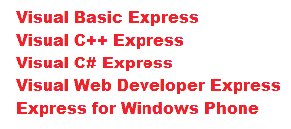

Other editions are Visual Studio Professional, Visual Studio Premium, Visual Studio Tools for Office, Visual Studio Ultimate, Visual Studio Team System and Test Professional

Visual Studio Version history

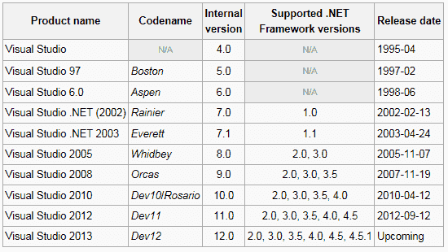

C# is designed for building a variety of applications that run on the .NET Framework. Before you start learning more about C# programming, it is important to understand the development environment and identify some of the frequently using programming tools in the Visual Studio IDE.

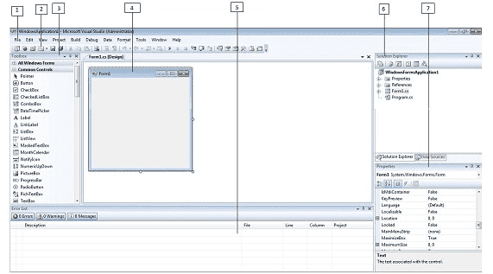

* 1. Menu Bar
* 2. Standard Toolbar
* 3. ToolBox
* 4. Forms Designer
* 5. Output Window
* 6. Solution Explorer
* 7. Properties Window

Combined with the .NET Framework, C# enables the creation of Windows applications, Web services, database tools, components, controls, and more. Visual Studio organizes your work in projects and solutions. A solution can contain more than one project, such as a DLL and an executable that references that DLL. From the following C# chapters you will learn how to use these Visual Studio features for your C# programming needs.

[**Next :  How to Create a C# Windows Forms Application**](http://csharp.net-informations.com/gui/cs_forms.htm)

* [How to Create a C# Windows Forms Application](http://csharp.net-informations.com/gui/cs_forms.htm)
* [C# Label Control](http://csharp.net-informations.com/gui/label.htm)
* [C# Button Control](http://csharp.net-informations.com/gui/button.htm)
* [C# TextBox Control](http://csharp.net-informations.com/gui/cs-textbox.htm)
* [C# ComboBox](http://csharp.net-informations.com/gui/cs-combobox.htm)
* [C# ListBox Control](http://csharp.net-informations.com/gui/cs-listbox.htm)
* [C# Checked ListBox Control](http://csharp.net-informations.com/gui/cs-checkedlistbox.htm)
* [C# RadioButton Control](http://csharp.net-informations.com/gui/cs-radiobutton.htm)
* [C# CheckBox Control](http://csharp.net-informations.com/gui/cs-checkbox.htm)
* [C# PictureBox Control](http://csharp.net-informations.com/gui/cs-picturebox.htm)
* [C# ProgressBar Control](http://csharp.net-informations.com/gui/cs-progressbar.htm)
* [C# ScrollBars Control](http://csharp.net-informations.com/gui/cs-scrollbars.htm)
* [C# DateTimePicker Control](http://csharp.net-informations.com/gui/cs-datetimepicker.htm)
* [C# Treeview Control](http://csharp.net-informations.com/gui/cs-treeview.htm)
* [C# ListView Control](http://csharp.net-informations.com/gui/cs-listview.htm)
* [C# Menu Control](http://csharp.net-informations.com/gui/cs-menu.htm)
* [C# MDI Form](http://csharp.net-informations.com/gui/cs-mdi-form.htm)
* [C# Color Dialog Box](http://csharp.net-informations.com/gui/cs-color-dialog-box.htm)
* [C# Font Dialog Box](http://csharp.net-informations.com/gui/cs-font-dialog-box.htm)
* [C# OpenFile Dialog Box](http://csharp.net-informations.com/gui/cs-openfile-dialog-box.htm)
* [C# Print Dialog Box](http://csharp.net-informations.com/gui/cs-print-dialog-box.htm)
* [keyPress event in C# , KeyDown event in C# , KeyUp event in C#](http://csharp.net-informations.com/gui/key-press-cs.htm)
* [How to create Dynamic Controls in C# ?](http://csharp.net-informations.com/gui/dynamic-controls-cs.htm)
* [Keep Form on Top of All Other Windows](http://csharp.net-informations.com/gui/form-on-top-cs.htm)
* [C# Timer Control](http://csharp.net-informations.com/gui/timer-cs.htm)

* [An overview of Microsoft C#](http://csharp.net-informations.com/overview/csharp-overview.htm)
* [C# Language Tutorial](http://csharp.net-informations.com/language/csharp-language-basic-tutorial.htm)
* [C# Statements Tutorial](http://csharp.net-informations.com/statements/csharp_statements_tutorial.htm)
* [C# Graphical User Interface Tutorial](http://csharp.net-informations.com/gui/gui_tutorial.htm)
* [C# Collection Tutorial](http://csharp.net-informations.com/collection/csharp-collection-tutorial.htm)
* [C# String Tutorial](http://csharp.net-informations.com/string/csharp_string_tutorial.htm)
* [C# File Operations Tutorial](http://csharp.net-informations.com/file/csharp-file-tutorial.htm)
* [C# Excel Tutorial](http://csharp.net-informations.com/excel/csharp-excel-tutorial.htm)
* [C# Crystal Reports Tutorial](http://csharp.net-informations.com/crystal-reports/csharp-crystal-reports-tutorial.htm)
* [CSharp Communication Tutorial](http://csharp.net-informations.com/communications/csharp-communications-tutorial.htm)
* [C# Ado.Net Tutorial and Source Code , c# database programming tutorial](http://csharp.net-informations.com/ado.net/csharp-ado.net-tutorial.htm)
* [C# ADO.NET data Providers Tutorial](http://csharp.net-informations.com/data-providers/csharp-dataproviders-tutorial.htm)
* [C# Dataset Tutorial](http://csharp.net-informations.com/dataset/csharp-dataset-tutorial.htm)
* [C# DataAdapater Tutorial](http://csharp.net-informations.com/dataadapter/csharp-dataadapater-tutorial.htm)
* [Csharp DataView Tutorial](http://csharp.net-informations.com/dataview/csharp-dataview-tutorial.htm)
* [Csharp Remoting Tutorial](http://csharp.net-informations.com/remoting/csharp-remoting-tutorial.htm)
* [C# XML Tutorial](http://csharp.net-informations.com/xml/csharp-xmltutorial.htm)
* [C# DataGridView Tutorial](http://csharp.net-informations.com/datagridview/csharp-datagridview-tutorial.htm)

[Facebook](https://www.facebook.com/netinformations) [Google+](https://plus.google.com/+rapsmk) [Twitter](https://twitter.com/netinformations)

  More Source Code :

Top of Form

 

Bottom of Form

Mail to :  [rapsmvk@gmail.com](mailto:rapsmvk@gmail.com)

net-informations.com (C) 2022    Founded by raps mk  
All Rights Reserved. All other trademarks are property of their respective owners.  
[SiteMap](http://net-informations.com/sitemap.htm)  | [Terms](http://net-informations.com/terms.htm)  | [About](http://net-informations.com/about.htm)